2023 Kanazawa Seiryo University

Short-term Japanese Language and Culture Program

Kanazawa Seiryo University will offer the 2023 Short-term Japanese Language and Culture Program for international students from our partner universities.

This program cultivates Japanese language and also provides Japanese cultural experiences. In addition, Kanazawa Seiryo University provides many opportunities to interact with Japanese students through supporting your study and events.

【Program Period】

Monday, July 10th – Friday, July 21st, 2023(For two weeks)

【Language Classes】

90min× 6 classes ※Japanese lesson is beginner’s level only.

【Activities】

Experiences Japanese cultural activities: tea ceremony, traditional craft, Japanese traditional clothing, calligraphy, Kanazawa city tour with Japanese students, day trip to Noto, company visit, interaction with Japanese students etc. (Activities will be changed per year)

*There is a possibility that activities will change in the future.

【Fee】

Program fee ----------------------------------------------JPY 70,000

Program fee includes: tuition, accommodation fee, ica card fee(transportation fee between share hotel and university), fees for field study　and activities.

Program fee does not include: airfare, domestic travel expenses, insurance, meals and other living expenses.

【Accommodation】

Accommodation options are either university student housing or a private shared hotel.

Application

Due date: Friday, April 14th, 2023

Please send back the application form and passport copies (cover page and photo page) to [iec@seiryo-u.ac.jp](mailto:iec@seiryo-u.ac.jp) by Friday, April 14th, 2023

**Notes**

・This program may be cancelled due to natural disasters or spread of infectious diseases, etc.

・If the University determines that it is necessary, you may be required to submit additional documents in addition to the application documents above.

For Inquiry

Kanazawa Seiryo University International Exchange Center

Address: 10-1Ushi, Gosho-machi, Kanazawa, Ishikawa, 920-8620, Japan

Phone: +81-76-253-3896

E mail: [iec@seiryo-u.ac.jp](mailto:iec@seiryo-u.ac.jp)

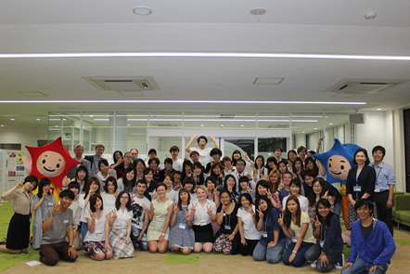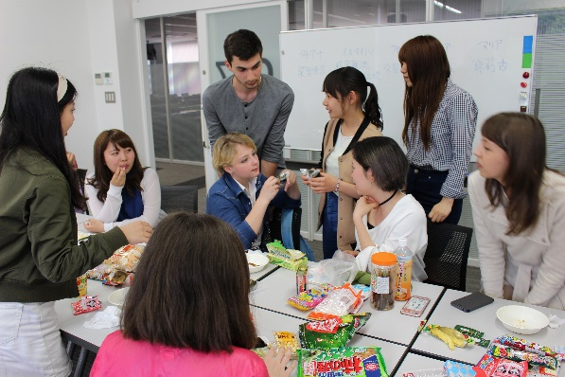

Welcome party　　　　　　　　Interaction with Japanese students in class

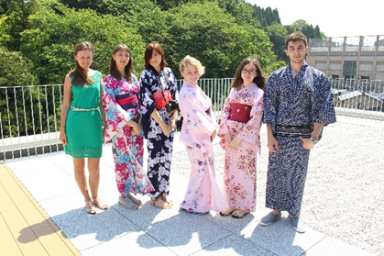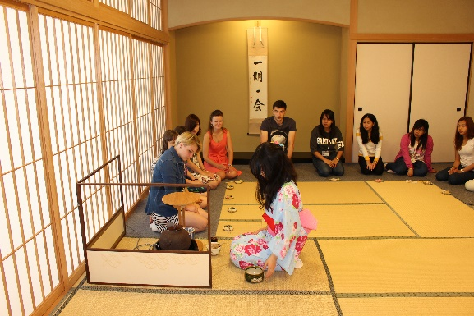

Traditional Japanese clothing　　　　　 Tea ceremony

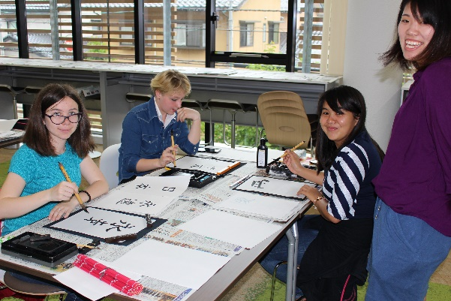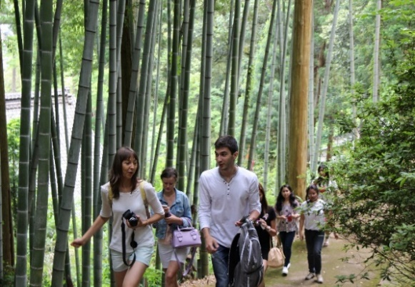

Calligraphy 　　　　　　　 Day trip